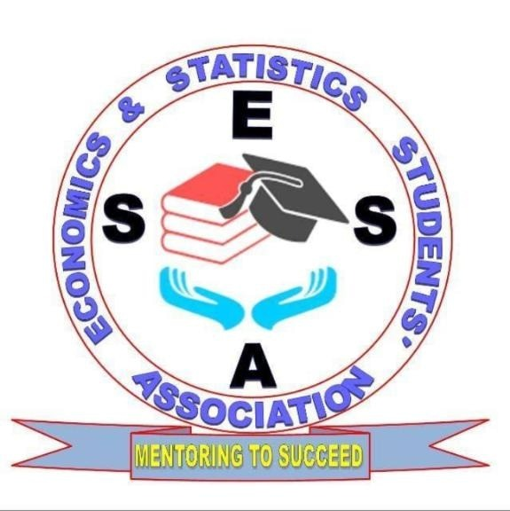

**Essa Club icial**

|  |  |  |  |
| --- | --- | --- | --- |
| **Numbers** | **Name** | **Executive Post** | **Year of Study** |
| 1. | Gordon Akuro | Chairperson | 3rd |
| 2 | Jessicah Wanyama | Vice-Chairperson | 3rd |
| 3 | Enos Kibet | Treasurer | 1st |
| 4 | Anourite Khabetsa | Secretary-General | 1st |
| 5 | Esther Wanjiku | Assistant Secretary-General | 1st |
| 6 | Ronald Digo | Organizing Secretary | 3rd |
| 7 | Antony Maina kinairu | Public Relation | 2rd |
| 8 | Fineas Odera | Chairperson of The Committee | 3rd |

**The Committee Officials 2022/2023**

|  |  |  |  |
| --- | --- | --- | --- |
| **Numbers** | **Name** | **Committee Post** | **Year Of Study** |
| 1 | Alice Wambua | Vice-Chairperson of Committee | 3rd |
| 2 | George Njule | Auditor General | 1st |
| 3 | Purity Jepkoech | Secretary-General | 1st |
| 4 | Benta Ochieng | Organizing Secretary | 2 |
| 5 | Wickliff Kimuyu | Public Relation Assistant | 1st |
| 6  7  8  9  10 | Issac Mumo musyoki  Masinde kilui Humphrey  Benson Wanyonyi  Clifton  Oloo Cecil | Marketing Officers | 2rd  1st  2rd  3rd  1st |

Chairperson of the commission patron of the club

Akuro Dr Umulker Ali

…………… …………………..